
T H E A D V E N T U R E S O F S I M B A A N D K I A R A



Design Appendix:

Character Diagrams

All Images, Characters, and Themes © 1994, 1995 The Walt Disney Company

Game Proposal and Game Ideas © 1999 Paradox Development

Character Diagrams

The diagrams contained within these pages are intended to be a reference guide for the art and coding team. Each of the characters in the game is explained, in so far as its function.

Some diagrams have not been drawn, pending visualization from the publisher. The function of the enemy has been stated, ready for the picture to be dropped in.

Player Characters
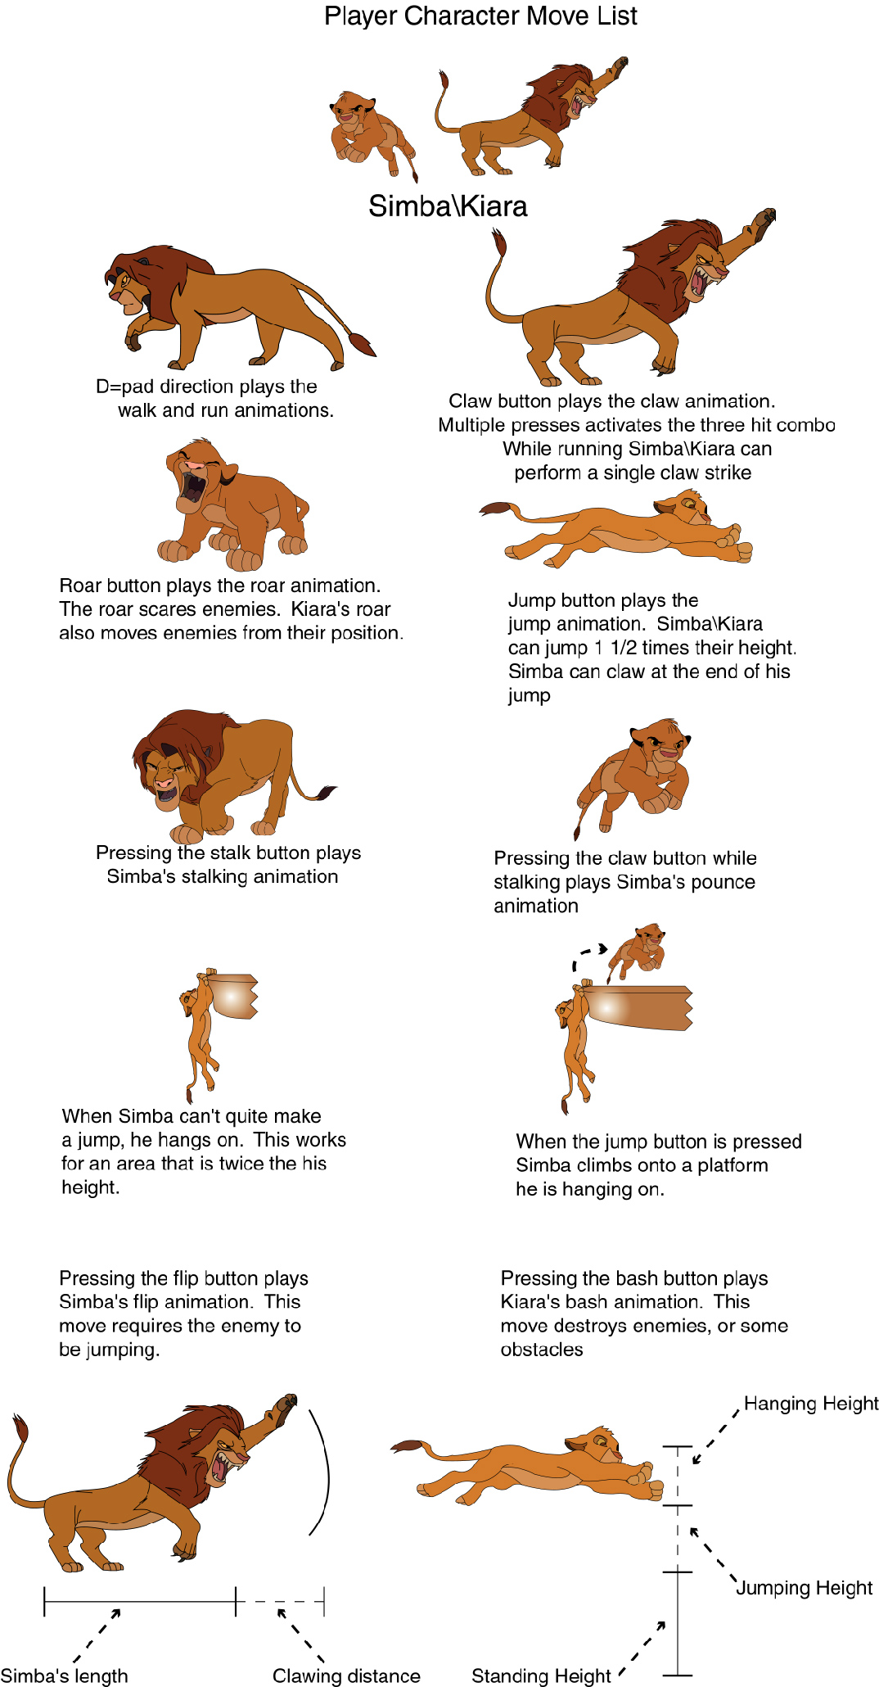

Enemies
